**PROJECT REPORT FORMAT**

**1.INTRODUCTION**

1.1.Project overview

1.2.purpose

**2.LITERATURE SURVEY**

2.1. existing problem

2.2 reference

2.3 problem statement definition

**3. IDEATION AND PROPOSED SOLUTION**

3.1Empathy map canvas

3.2.ideation and brainstorming

3.3 proposed solution

3.4 problem solution fit

**4.REQUIREMENT ANALYSIS**

4.1 functional requirement

4.2 non functional requirement

**5.PROJECT DESIGN**

5.1data flow diagram

5.2 solution and technical architecture

5.3user stories

**6.PROJECT PLANNING AND SCHEDULING**

6.1.sprint planning and estimation

6.2.sprint delivery schedule

6.3.report from JIRA

**7.CODING AND SOLUTIONING**

7.1.feature 1

7.2.feature 2

7.3.data base schema

**8.TESTING**

8.1.TEST CASE

8.2.USER ACCEPTANCE TESTING

**9.RESULTS**

9.1 performance metrics

**10.ADVANTAGES & DISADVANTAGES**

**11.CONCLUTION**

**12.FUTURE SCOPE**

**13.APPENDIX**

**INTRODUCTION**

As the name shows,the app delivery nutrition-based analytics and data to its user and

          becoming a leading platform for delivering AI fitness services. It uses mathematical and

          natural language processing(NLP)models to deploy predictive analysis for compilation.

**1.1 PROJECT OVERVIEW**

Nowadays new dietry assessment and nutrition analyysis tools enable more opportunities to

     to help people understand their daily eating habits,exploring nutrition patterns and maintain a

     a healthy diet.

**1.2 PURPOSE**

Nowadays help people understand their daily eating habits,exploring nutrition patterns and

    maintain a healthy diet.

**2.LITERATURE SURVEY**

**2.1 EXISTING PROBLEM**

AI algorithm may help better understand and predict the complex and non linear interaction

**2.2 REFERENCE**

  The nutrition related data and health outcomes,particulary when large amount of data need

        to be structured and intergrated such as in metabolomics

**2.3 PROBLEM STATEMENT DEFINITION**

        As the world grows more fitness-consciouds with passing time , the demand for

        technological solution and catter to this demand this diversifying .

         Lately  a number of start up in india and world wide are using predictive analytics

        artificial interlligence and natural language processing to help scross of fitness caloric

        their nutrition and intake

**3.IDEATION & PROPOSED SOLUTION**

**3.1 EMPATHY MAP CANVAS**

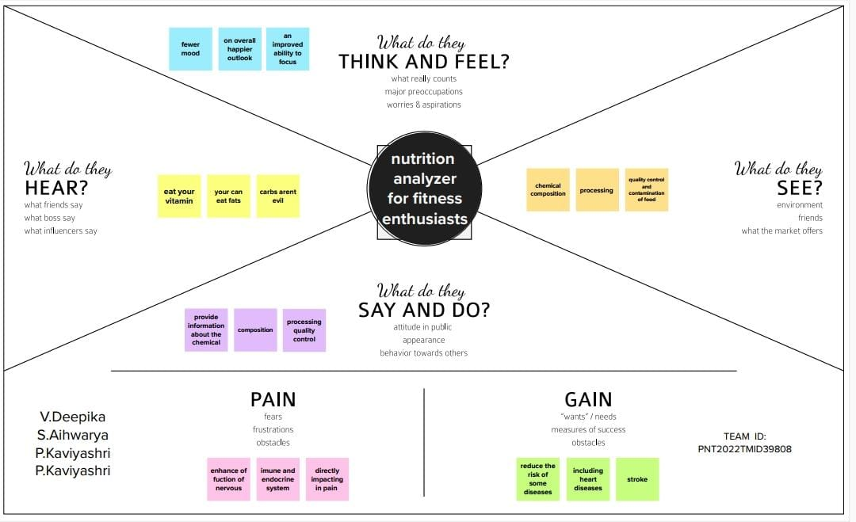

**3.2 IDEATION & BRAINSTROMING**

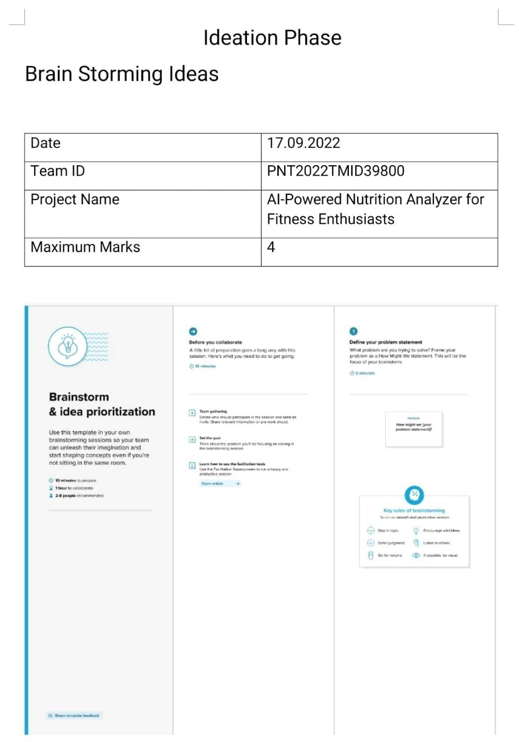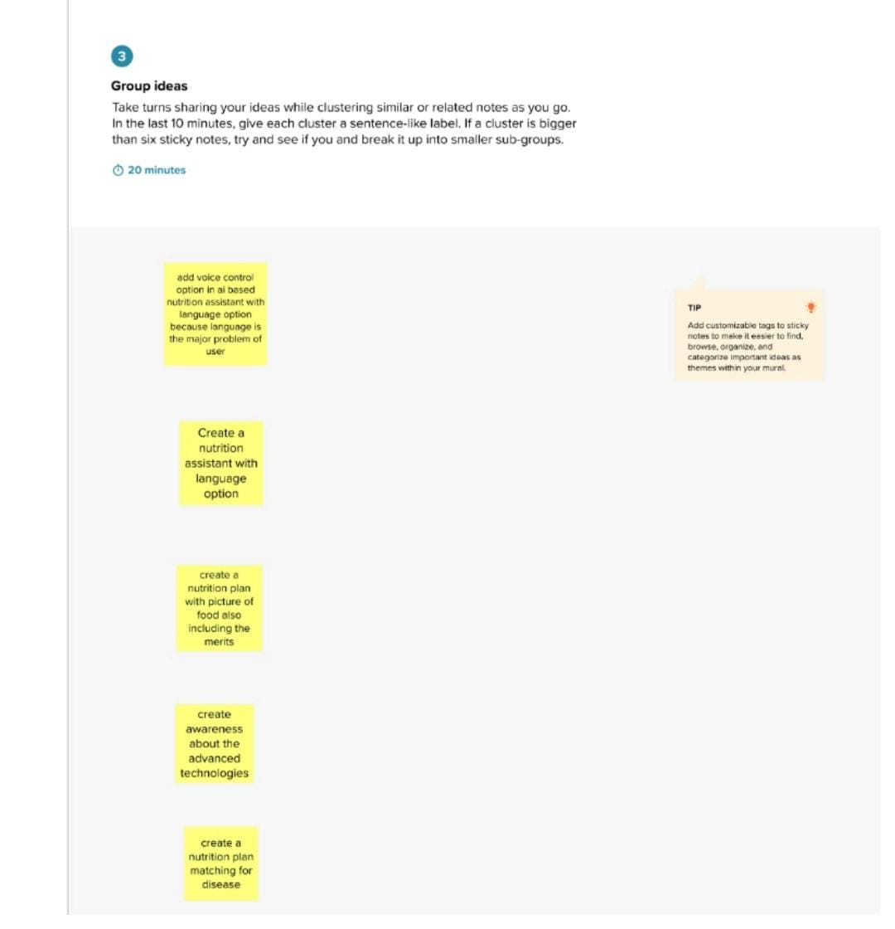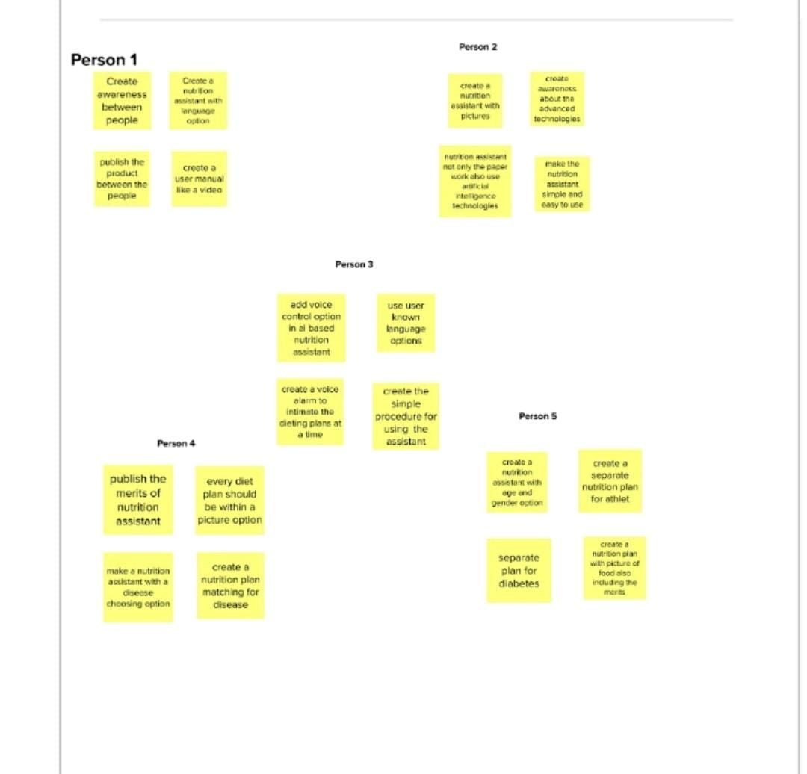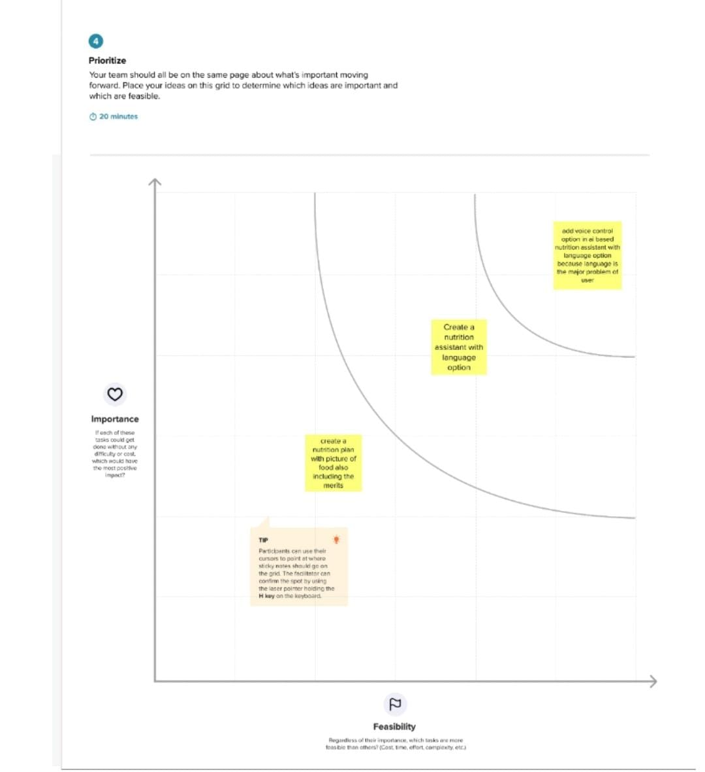

**3.3 PROPOSED SOLUTION**

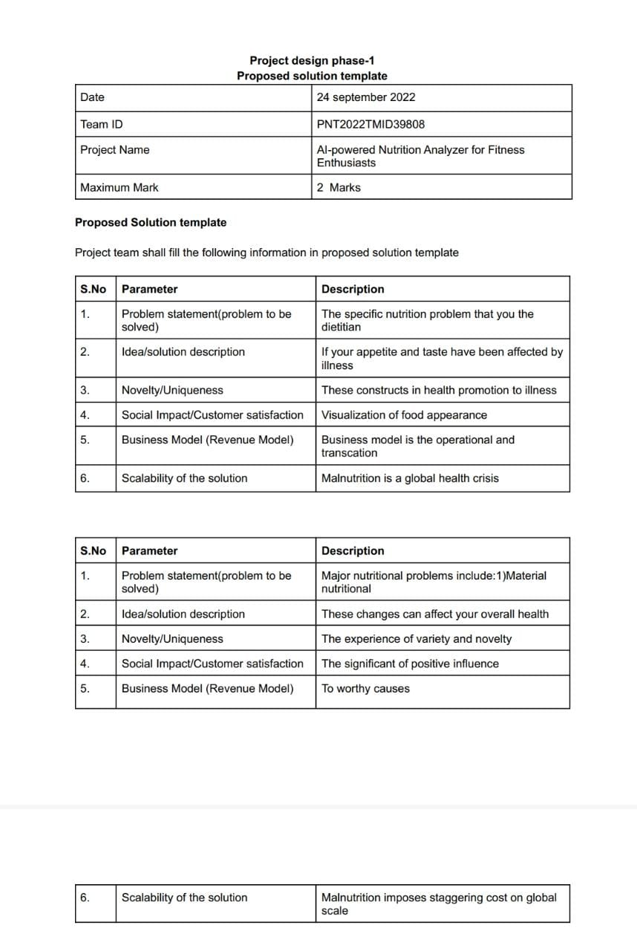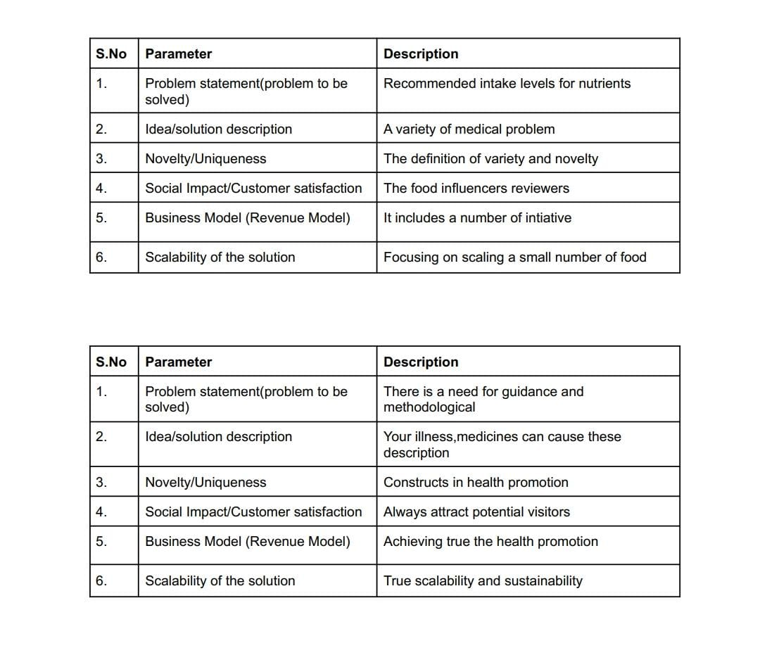

**3.4 PROBLEM SOLUTION FIT**

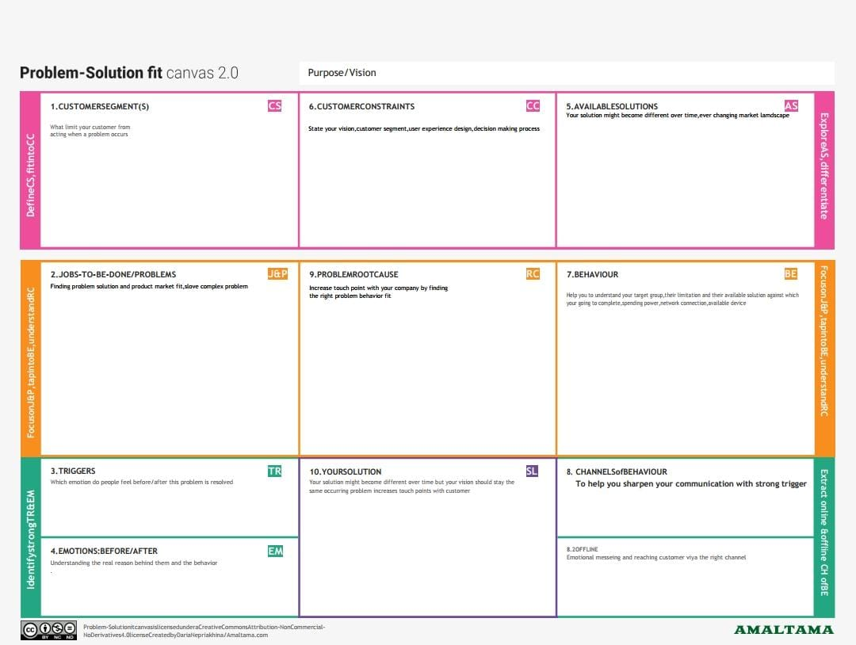

**4.REQUIREMENT ANALYSIS**

**4.1 FUNCTIONAL REQUIREMENT**

The functional requriment document defines justified target states for information

       and robotics partner.technical partners can be then define their ai solution technical

       requirement to match the concrete need of the clinical partners

**4.2 NON-FUNCTIONAL REQUIREMENT**

Non -functional requirement define system attribute such as     security,reliability,performance,maintainability,scalability and usability. they serve as consraints on the design of the system across the different backlogs.

**5.PROJECT DESIGN**

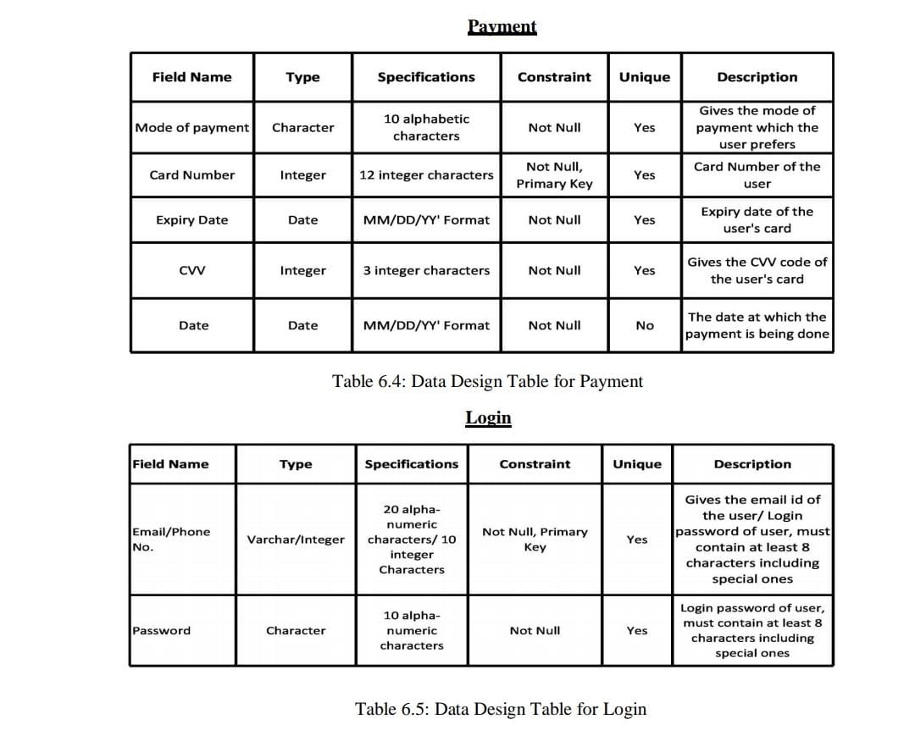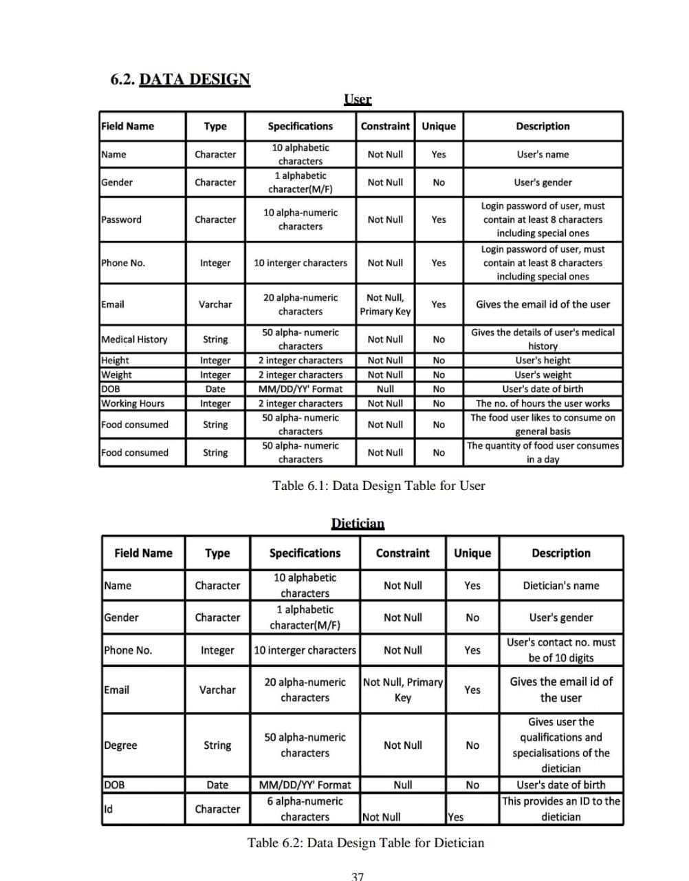

**5.1 DATA FLOW DIAGRAMS**

Graphical representation using  standardized set of symbolls and notation to describe

          a business operation through data movement.

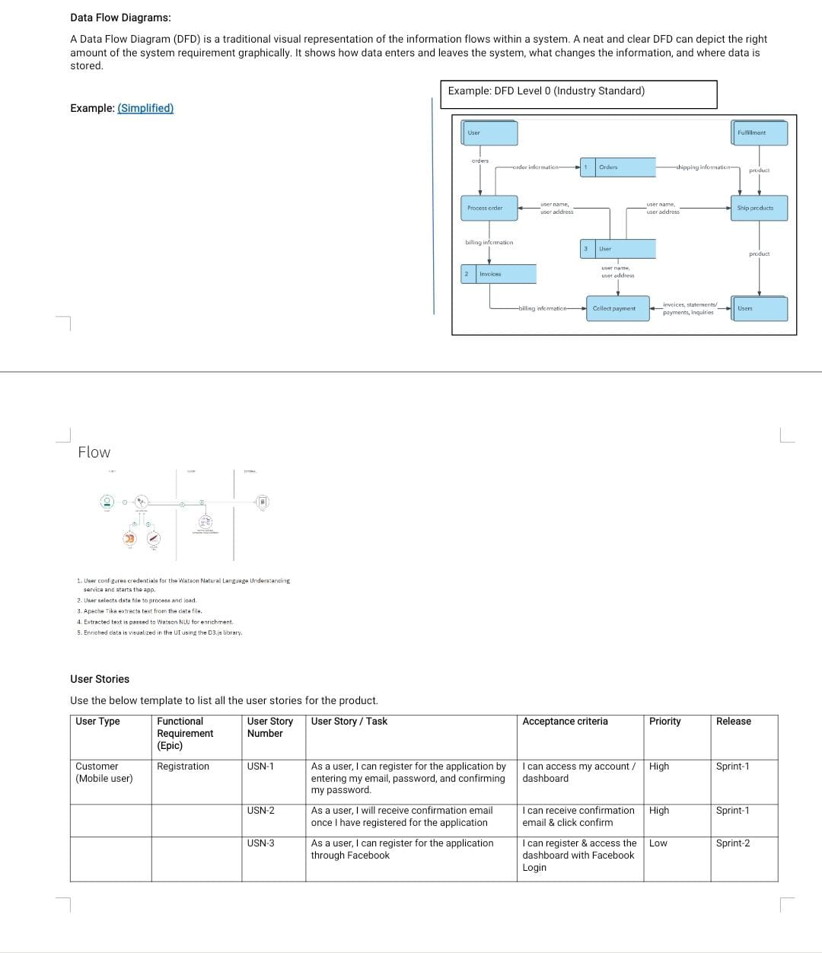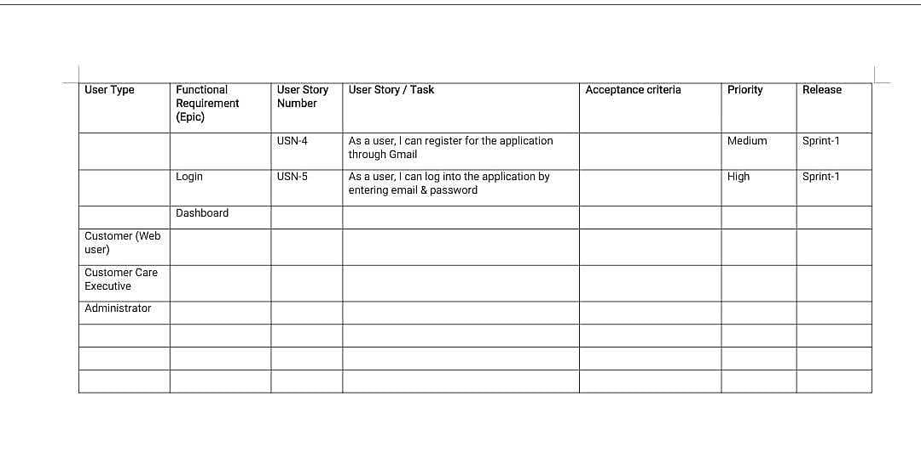

**5.2 SOLUTION AND TECHNICAL ARCHITECTURE**

Solution architects are most similar to project manager,ensuring that all parties,

                including stakeholders,are on he same page moving in their right direction at

                all stages.technical architects manage all activities leading to the successful

                implementation of a new application.

**5.3 USER STORIES**

This is the outcome of TM forum member collaboration to identify the uses of AI

                 in service provider environment,and help catolog business and technical user

                 stories,uses cases and test case.

**6. PROJECT PLANNING &SCHEDULING**

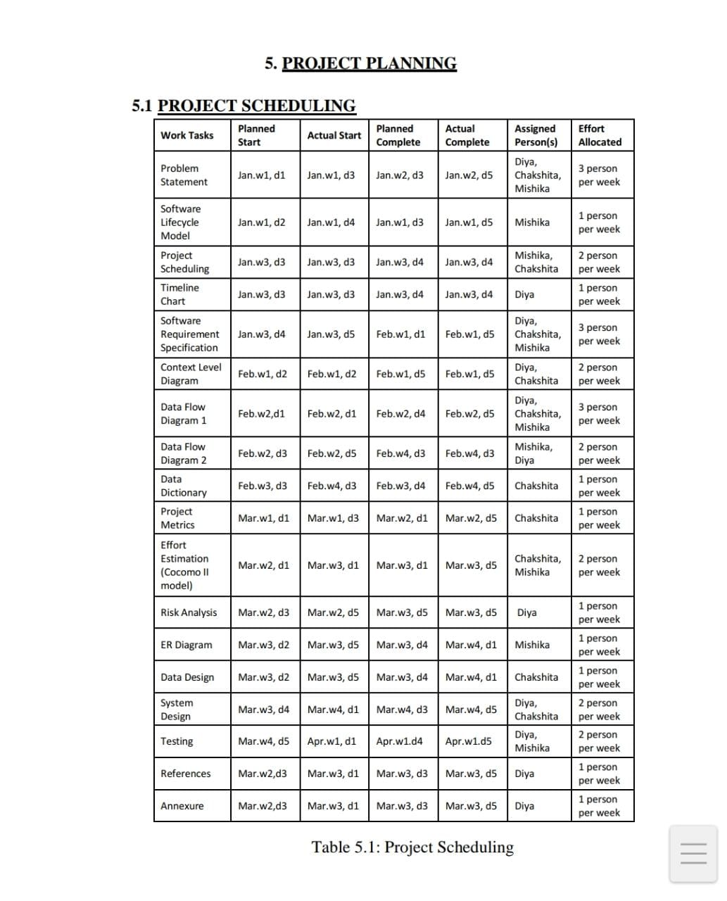

**6.1 SPRINT PLANNING & ESTIMATION**

Sprint planning isan event in scrum that kicks off the sprint.the purpose of spirint

                     planning is to define what can be delivered in the sprint planning is done in the

                     collaboration with the whole scrum team.

**6.2 SPRINT DELIVERY SCHEDULE**

In case you're unfamiliar,a sprint schedule is a document that outlines sprint in

                   planning from end to end.its one of the first steps in the agile sprint planning

                   process-and something that requires communication.

**6.3 REPORT FROM JIRA**

The app artificial intelligence for issue analytics provided features that use machine

                   learning ans visulization technicques that allow team membersand manager to more

                   effectively manage project.

**7. CODING  & SOLUTIONING(Explain the features added in the project along with code)**

**7.1 FEATURE 1**

Personal coach and mentor

                  Account creation

                  Wearable andNon-Wearable

                  Gamification

                  Nutrition tracking

**7.2 FEATURE 2**

Costomised diet plans

                  Sharing on social media

                  Push notification system & reminders

                  Geolocation integration

                  Vedio tutorials

**7.3 DATABASE SCHEMA**

A database schema is considered the blueprint of a database which describes

             how the data may relate to other tables or other data models.however the schema does

             other table.

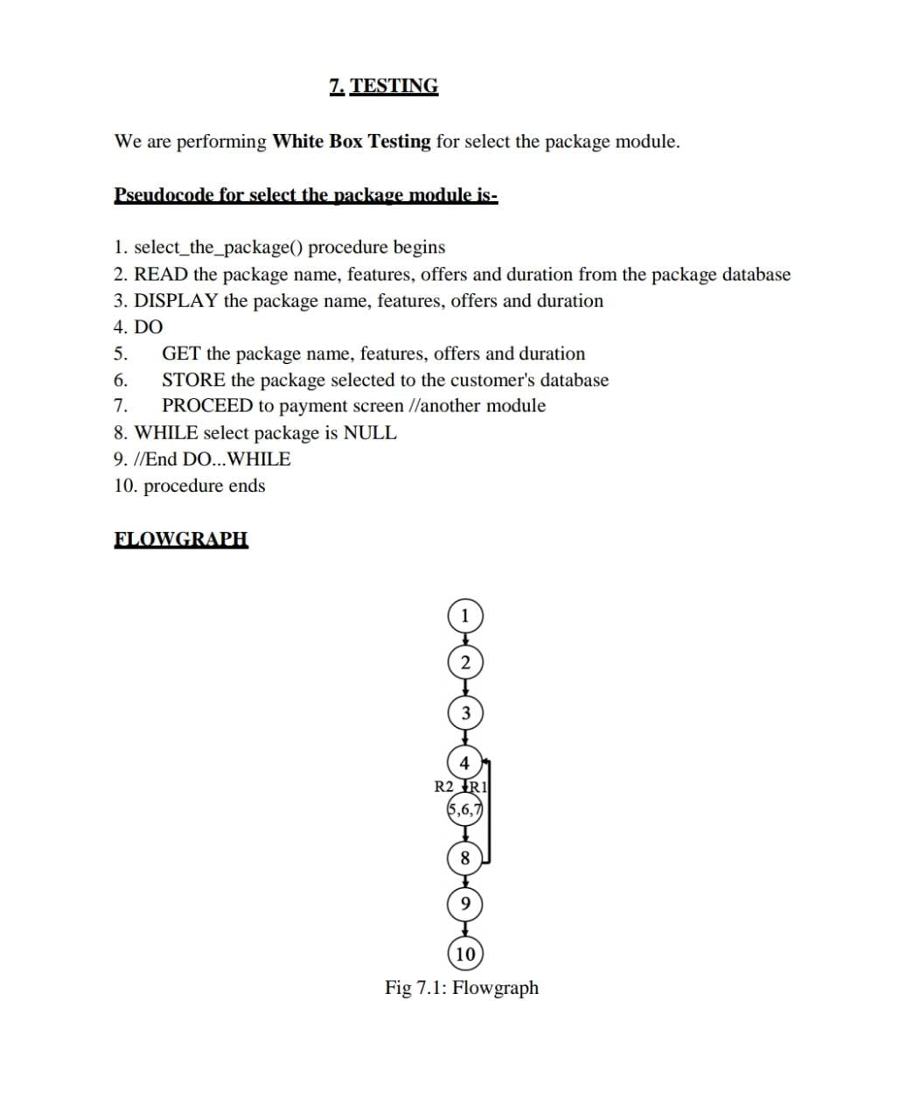

**8.1 TEST CASES**

Automated testing.

                AI Testing 101.

                Acceptance testing

**8.2 USER ACCEPTANCE TESTING**

Artificial intelligence is more and more present in everyday application and service

              and the end-user are getting.

**9. RESULTS**

**9.1 PERFORMANCE METRICS**

Evaluting the performance of amachine learning model is one of the important steps.

**9.2 SOURCE CODE**

Login code

<!DOCTYPE html>

<html lang="en">

<head>

<meta charset="UTF-8">

<title>user login</title>

<link rel="shortcut icon" type="image/jpg" href="../static/img3.jpg">

<link href="../static/login.css" rel="stylesheet">

</head>

<body>

<header>

<ul class="nav-area">

<li><a href="/">Home</a></li>

<li><a href="/login">User Login</a></li>

<li><a href="/registertemp">Register</a></li>

</ul>

<div class="contact-form">

<h2> User login</h2>

<form action="/logindata" method="POST">

<p>Username</p><input placeholder="Enter username" type="text" name="username">

<p>Password</p><input placeholder="Enter Password" type="password" name="password">

<span class="alert {{indicator}}">{{b}}</span>

<input type="submit" value="Sign in">

</form>

<div class="links">

<p>Not yet registered..?? <a href="/registertemp"> Click here</a></p>

</div>

</div></header>

</body>

</html>

Register code

<html lang="en">

<head>

<meta charset="UTF-8">

<meta http-equiv="X-UA-Compatible" content="IE=edge">

<meta name="viewport" content="width=device-width, initial-scale=1.0">

<title>Registration</title>

<link rel="shortcut icon" type="image/jpg" href="../static/img3.jpg">

<link rel="stylesheet" href="../static/register.css">

</head>

<body>

<header><div class="wrapper">

<ul class="nav-area">

<li><a href="/">Home</a></li>

<li><a href="/login">User Login</a></li>

<li><a href="/registertemp">Register</a></li>

</ul>

<div class="registration_form">

<div class="title">

Registration Form

</div>

<form action="/uploaddata" method="POST">

<div class="form_wrap">

<div class="input_grp">

<div class="input_wrap">

<label for="firstname">First Name</label>

<input type="text" id="firstname" name="firstname" placeholder="firstname">

</div>

<div class="input_wrap">

<label for="lastname">Last Name</label>

<input type="text" id="lastname" name="lastname" placeholder="lastname">

</div>

</div>

<div class="input_wrap">

<label for="username">username</label>

<input type="text" id="username" name="username" placeholder="username">

</div>

<div class="input_wrap">

<label for="email">Email</label>

<input type="email" id="email" name="email" placeholder="email">

</div>

<div class="input_wrap">

<label for="password">Password</label>

<input type="password" id="password" name="password" placeholder="password">

</div>

<div class="input_wrap">

<label for="address">State</label>

<input type="text" id="address" name="address" placeholder="state">

</div>

<div class="input_wrap">

<input type="submit" value="Register Now" class="submit_btn">

</div>

</div>

</form>

<br>

<span class="alert {{indicator}}">{{a}}</span>

<div class="links" style="margin-top: 10px;">

<p>Already a member then login.. <a href="/login" style="text-decoration: none; border-bottom: 1px solid rgb(231, 33, 33);border-radius: 0px;">Click here</a></p>

</div>

</div>

</div>

</header>

</body>

</html>

**10. ADVANTAGES & DISADVANTAGES**

**ADVANTAGES**

It defines a more powerfull and more usefulll computers.

**DISADVANTAGES**

The implementation cost of AI is very high.

**11. CONCLUSION**

The computer based face recognition industry has made much useful advancement

                 in thepast decade.however the need for higher accuracy systm remains.

                 through the determination and commitment end of industry.

**12.FUTURE SCOPE**

The goal is to create computer intelligence programmers that can be handle real-time

               problem and help organization and everyday people achieve their goals.

               machine games,speech recognition,language detection,robotics.